Web Service Practical

Web service model is a standard communication between client and server scripting application, it provides multiple uses for different types of software application as it designed to provide a multiple functionality to the client that visited and uses the website.

There are multiple types of web service

In this project, I will make a simple web service app using SOAP

SOAP is a messaging protocol specification for exchanging structured information in the implementation of web services in computer networks. It is base on XML protocol, gives the ability to integrate with other program apps.  
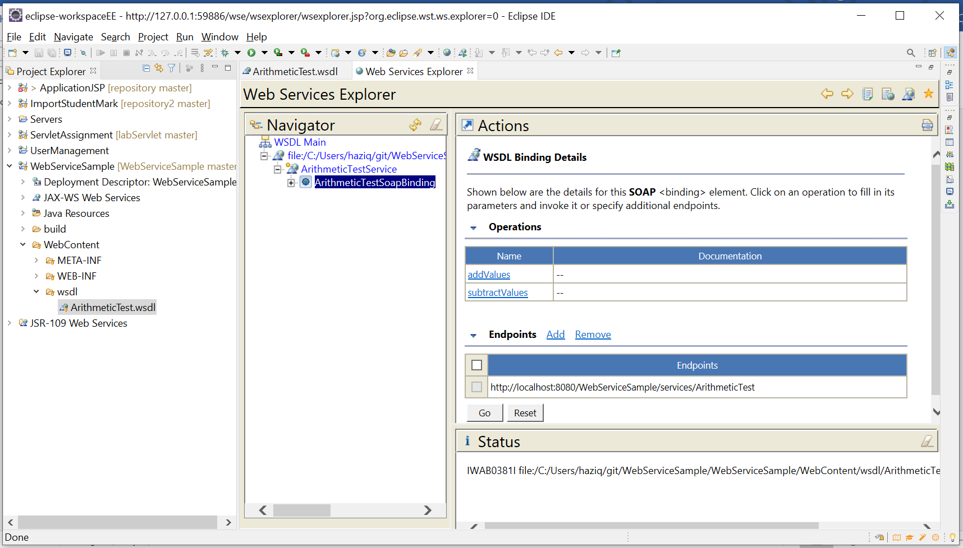  
  
here are the web service explorer, we are testing the functionality by adding the input value in the function and setting the endpoint  
  
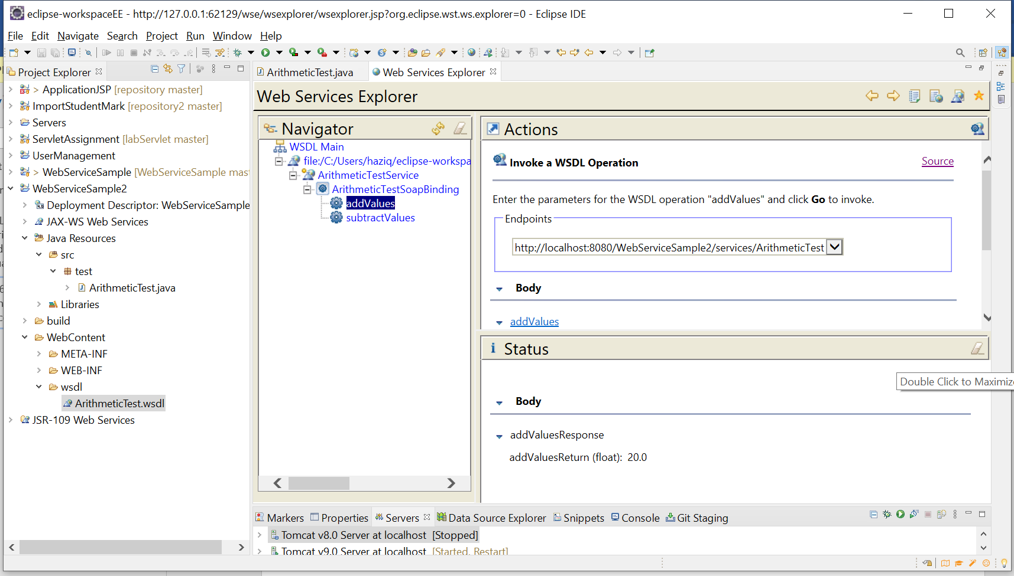  
  
The results will show the SOAP envelope message, the request and response.  
  
Here are the envelope  
  
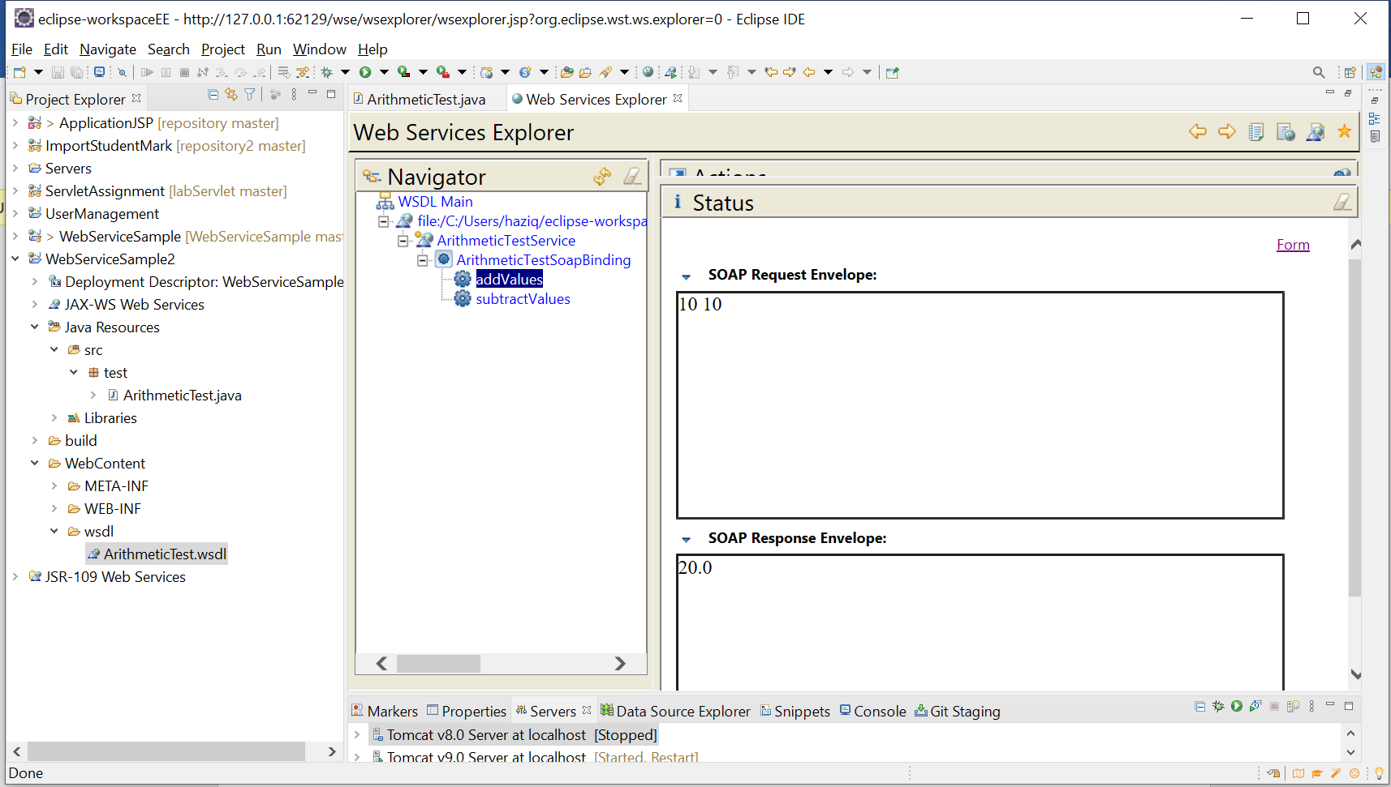

Another type of test (It is Inside Branch2 of the repository) :

